Low Level Design(LLD)

Oil Price Predictor

Contents:

1. [Introduction](https://docs.google.com/document/d/11ZsH8kpfHudKxEpP882RrH1Ay4Ax44Sf/edit#heading=h.gjdgxs) 
   1. [What is Low-Level design document?](https://docs.google.com/document/d/11ZsH8kpfHudKxEpP882RrH1Ay4Ax44Sf/edit#heading=h.30j0zll)
   2. [Scope](https://docs.google.com/document/d/11ZsH8kpfHudKxEpP882RrH1Ay4Ax44Sf/edit#heading=h.1fob9te)
2. [Architecture](https://docs.google.com/document/d/11ZsH8kpfHudKxEpP882RrH1Ay4Ax44Sf/edit#heading=h.3znysh7)
3. [Architecture Description](https://docs.google.com/document/d/11ZsH8kpfHudKxEpP882RrH1Ay4Ax44Sf/edit#heading=h.2et92p0) 
   1. [Data Description](https://docs.google.com/document/d/11ZsH8kpfHudKxEpP882RrH1Ay4Ax44Sf/edit#heading=h.tyjcwt)
   2. [Web Scrapping](https://docs.google.com/document/d/11ZsH8kpfHudKxEpP882RrH1Ay4Ax44Sf/edit#heading=h.3dy6vkm)
   3. [Data Transformation](https://docs.google.com/document/d/11ZsH8kpfHudKxEpP882RrH1Ay4Ax44Sf/edit#heading=h.1t3h5sf)
   4. [Data Insertion into Database](https://docs.google.com/document/d/11ZsH8kpfHudKxEpP882RrH1Ay4Ax44Sf/edit#heading=h.4d34og8)
   5. [Export Data from Database](https://docs.google.com/document/d/11ZsH8kpfHudKxEpP882RrH1Ay4Ax44Sf/edit#heading=h.2s8eyo1)
   6. [Data Pre-processing](https://docs.google.com/document/d/11ZsH8kpfHudKxEpP882RrH1Ay4Ax44Sf/edit#heading=h.17dp8vu)
   7. [Data Clustering](https://docs.google.com/document/d/11ZsH8kpfHudKxEpP882RrH1Ay4Ax44Sf/edit#heading=h.3rdcrjn)
4. [Model Building](https://docs.google.com/document/d/11ZsH8kpfHudKxEpP882RrH1Ay4Ax44Sf/edit#heading=h.26in1rg)
5. [Data from User](https://docs.google.com/document/d/11ZsH8kpfHudKxEpP882RrH1Ay4Ax44Sf/edit#heading=h.lnxbz9)
6. [Data Validation](https://docs.google.com/document/d/11ZsH8kpfHudKxEpP882RrH1Ay4Ax44Sf/edit#heading=h.35nkun2)
7. [User Data Inserting into Database](https://docs.google.com/document/d/11ZsH8kpfHudKxEpP882RrH1Ay4Ax44Sf/edit#heading=h.1ksv4uv)
8. [Data Clustering](https://docs.google.com/document/d/11ZsH8kpfHudKxEpP882RrH1Ay4Ax44Sf/edit#heading=h.44sinio)
9. [Model Call for Specific Cluster](https://docs.google.com/document/d/11ZsH8kpfHudKxEpP882RrH1Ay4Ax44Sf/edit#heading=h.2jxsxqh)
10. [Recipe Recommendation & Saving Output in Database](https://docs.google.com/document/d/11ZsH8kpfHudKxEpP882RrH1Ay4Ax44Sf/edit#heading=h.z337ya)
11. [Deployment](https://docs.google.com/document/d/11ZsH8kpfHudKxEpP882RrH1Ay4Ax44Sf/edit#heading=h.3j2qqm3)
12. [Unit Test Cases](https://docs.google.com/document/d/11ZsH8kpfHudKxEpP882RrH1Ay4Ax44Sf/edit#heading=h.1y810tw)

1. Introduction
2. What is Low-Level design document?

The goal of LLD or a low-level design document (LLD) is to give the internal logical design of the actual program code for Food Recommendation System. LLD describes the class diagrams with the methods and relations between classes and program specs. It describes the modules so that the programmer can directly code the program from the document.

1. Scope

Low-level design (LLD) is a component-level design process that follows a step-by-step [refinement](https://en.wikipedia.org/wiki/Refinement_(computing)) process. This process can be used for designing data structures, required software architecture, source code and ultimately, performance algorithms. Overall, the data organization may be defined during requirement analysis and then refined during data design work

1. Architecture

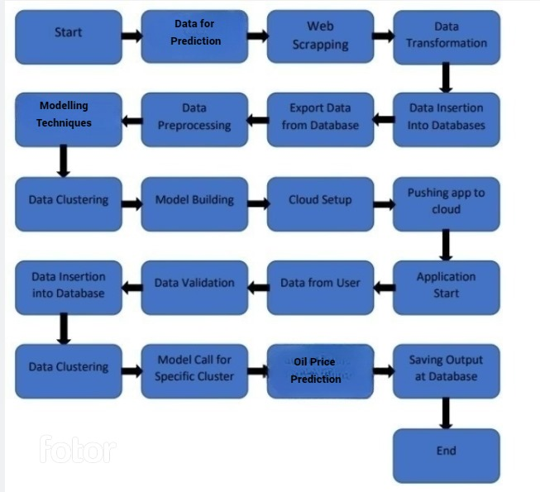

1. Architecture Description
2. Data Description

The Dataset Contains the data’s of the oil prices starting from 2000 to 2018 and consists of more thank 1k+ data’s.

1. Web Scrapping

In order to create a more complete oil price prediction we will need some more datasets which will contain much more critical values along with prices.

1. Data Transformation

In the Transformation Process, we will convert our original dataset which is in JSON format to CSV Format. And will merge it with the Scrapped dataset.

1. Data Insertion into Database
2. Database Creation and connection - Create a database with name passed. If the database is already created, open the connection to the database.
3. Table creation in the database.
4. Insertion of files in the table

1. Export Data from Database

Data Export from Database - The data in a stored database is exported as a CSV file to be used for Data Pre-processing and Model Training.

1. Data Pre-processing

Data Pre-processing steps we could use are Null value handling, Imbalanced data set handling, Handling columns with standard deviation zero or below a threshold, etc.

1. Data Clustering

Many algorithms have been used in order to improve the accuracy of the model such as linear regression,DecisionTreeClassifier and also XGBoost.

1. Model Building

After clusters are created, we will find the best model for each cluster. For each cluster, algorithms will be passed with the best parameters derived from DecisionTreeClassfier. We will calculate the AUC scores and r2 score for models and select the model with the best score. Similarly, the models will be selected for each cluster. All the models for every cluster will be saved for use in Prediction.

1. Data from User

Here we will collect Numerical data from user such as Date,Month and year so that the prediction model can act according to the user commands and provide the result with best performance.

1. Data Validation

Here Data Validation will be done, given by the user

1. User Data Inserting into Database

Collecting the data from the user and storing it into the database. The database can be either MySQL or Mongo DB.

1. Data Clustering

The model created during training will be loaded, and clusters for the user data will be predicted.

1. Model Call for Specific Cluster

Based on the cluster number, the respective model will be loaded and will be used to predict the data for that cluster.

1. Oil Price Prediction

Final prediction takes place here where the model operate over the user inputs and provide the result with high accuracy as possible.

1. Deployment

We will be deploying the model to Streamlit cloud.

This is a workflow diagram for the Oil Price Predictor.

1. Unit Test Cases

|  |  |  |
| --- | --- | --- |
| **Test Case Description** | **Pre-Requisite** | **Expected Result** |
| Verify whether the Application URL is  accessible to the user | 1. Application URL  should be defined | Application URL should be  accessible to the user |
| Verify whether the Application loads completely for the user when the URL is accessed | 1. Application URL is accessible 2. Application is deployed | The Application should load completely for the user when the URL is accessed |
| Verify whether the User is able to sign  up in the application | 1. Application is  accessible | The User should be able to sign up  in the application |
| Verify whether user is able to successfully login to the application | 1. Application is accessible 2. User is signed up to the application | User should be able to successfully login to the application |
| Verify whether user is able to see input fields on logging in | 1. Application is accessible 2. User is signed up to the application 3. User is logged in   to the application | User should be able to see input fields on logging in |
| Verify whether user is able to edit all input fields | 1. Application is accessible 2. User is signed up to the application 3. User is logged in to the application | User should be able to edit all input fields |
| Verify whether user gets Submit button to submit the inputs | 1. Application is accessible 2. User is signed up to the application 3. User is logged in to the application | User should get Submit button to submit the inputs |
| Verify whether user is presented with Predicted results on clicking  Predict. | 1. Application is accessible 2. User is signed up to the application 3. User is logged in   to the application | User should be presented with predicted results on clicking  Predict. |
| Verify whether the predicted results are in accordance to the selections user made | 1. Application is accessible 2. User is signed up to the application 3. User is logged in to the application | The predicted results should be in accordance to the selections user made |
| Verify whether user has options to filter values as well | 1. Application is accessible 2. User is signed up | User should have options to filter the date,day and month |

|  |  |  |
| --- | --- | --- |
|  | to the application  3. User is logged in to the application |  |
| Verify whether KPIs modify as per the user inputs for the user's health | 1. Application is accessible 2. User is signed up to the application 3. User is logged in to the application | KPIs should modify as per the user inputs for the user's health |
| Verify whether the KPIs indicate details of the suggested recipe | 1. Application is accessible 2. User is signed up to the application 3. User is logged in to the application | The KPIs should indicate details of the suggested recipe |

Thank You……..